**PROGRAM1: FIBONACCI SERIES NUMBER LESS THAN 100.**

<?php

$num=0;

$n1=0;

$n2=1;

echo"<h3>Fibonacci Series numbers less than:100</h3>";

echo"\n";

echo $n1.''.$n2.'';

while($num<10)

{

$n3=$n2+$n1;

echo$n3.'';

$n1=$n2;

$n2=$n3;

$num=$num+1;

}

?>

**OUTPUT:**

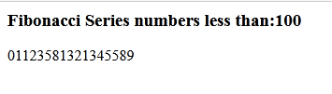

**PROGRAM 2: FUNCTION CALL**

<?php

$num_of_calls=0;

print("GLOBAL VARIABLES IN FUNCTION<p>");

function disp($txt)

{

global $num_of_calls;

$num_of_calls++;

print"<h1>$num_of_calls.$txt</h1>";

}

disp("BCA");

disp("MCA");

?>

**OUTPUT:**

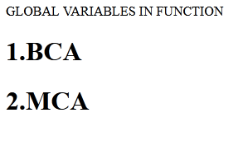

**PROGRAM 3: ARRAY PUSH(),POP(),MERGE()**

<?php

$a1=array(1,3,5);

$a2=array(2,4,6);

print"ARRAY FUNCTIONS";

echo"<br><br>1.NUMBER OF VALUES IN THE ARRAY:";

echo count($a1);

echo"<br><br>2.VALUES IN THE ARRAY:";

foreach($a1 as$i)

{

print"<br><br>".$i;

}

//array_push()

array_push($a1,7);

echo"<br><br>ARRAY AFTER PUSH:";

foreach($a1 as$i)

{

print"<br><br>".$i;

}

//array_pop()

$del=array_pop($a1);

print"<br><br>DELETED ELEMENT:".$del;

echo"<br><br>ARRAY AFTER POP:";

foreach($a1 as $i)

{

print"<br><br>".$i;

}

//array_merge()

$m=array_merge($a1,$a2);

echo"<br><br>ARRAY AFTER MERGING:";

foreach($m as $i)

{

print"<br><br>".$i;

}

?>

**OUTPUT:**

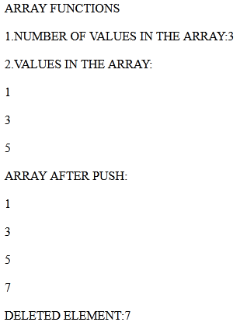

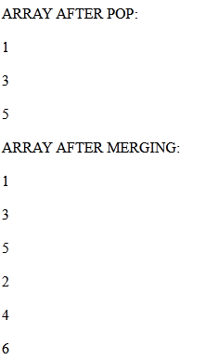

**PROGRAM 4: BIRTH DAY COUNTDOWN SCRIPT**

First.php

</title>

</head>

<body>

<form action="second.php" method="POST">

Enter Name<input type="text" name="name" size="40" />

ENTER NEXT DOB:

<input type="date" name="dob" size="15"/>

<input type="submit" value="CLICK HERE"name ="click"/>

</form>

</body>

</html>

Second.php

<html>

<body>

<?php

$n=$_POST["name"];

$dob=$_POST["dob"];

$today=time();

$your_date= strtotime($dob);

$datediff=$your_date-$today;

echo"HELLO".$n;

echo"<br><br>YOUR BIRTHDAY COMES IN".floor($datediff/(60*60*24))." DAYS";

echo"<br><br>YOUR BIRTHDAY COMES IN".floor($datediff/(60*60))." HOURS";

echo"<br><br>YOUR BIRTHDAY COMES IN".floor($datediff/(60))." MIN";

echo"<br><br>YOUR BIRTHDAY COMES IN".floor($datediff/(60))." SECONDS";

?>

</body>

</html>

**OUTPUT:**



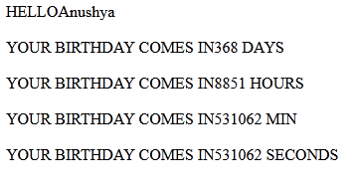

**PROGRAM 5: NUMBER GUESSING PROGRAM**

<html>

<form action=""method="POST">

Guess a number between 1 to 10;

<input type="text"name="number_entered" value='1-10'/><br><br>

Result:

<br><br>

<input type="submit"name="submit" value="OK CLICK HERE TO VIEW THE RESULT"/><br><br>

</form>

</html>

<?php

$number=$_POST['number_entered'];

$submitbutton=$_POST['submit'];

$randomnumber=mt_rand(1,10);

if($submitbutton)

{

if(($number>0)&&($number<11))

{

if($number!=$randomnumber)

{

echo"Incorrect guess.The correct answer was $randomnumber. Try again";

}

else

{

echo"$random" . “” . "" . "r is the correct guess.You got it right.";

}

}

}

?>

**OUTPUT:**

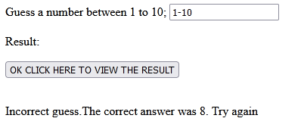

**PROGRAM 6: ARITHMETIC OPERATION**

<html>

<head>

<title>My addition page</title>

</head>

<body>

<form action="" method="post">

NUMBER1:<input name="first"><br>

NUMBER2:<input name="second"><br>

SELECTION:

<br><input type="radio" name="op1" value="+">ADD

<br><input type="radio" name="op1" value="+">SUB

<br><input type="radio" name="op1" value="+">MUL

<br><input type="radio" name="op1" value="+">DIV

<br><input type="submit" name="SUBMIT">

</form>

</body>

</html>

<?php

if(isset($_POST['SUBMIT']))

{

$first=$_POST["first"];

$second=$_POST["second"];

if($_POST['op1']=="+")

{

echo $first+$second;

}

if($_POST['op1']=="-")

{

echo $first-$second;

}

if($_POST['op1']=="*")

{

echo $first*$second;

}

if($_POST['op1']=="/")

{

echo $first/$second;

}

}

?>

**OUTPUT:**

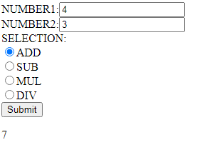

**PROGRAM 7 : CREATE COOKIE USING PHP**

<?php

$cookie_name = "user";

$cookie_value = "John Doe";

setcookie($cookie_name, $cookie_value, time() + (86400 * 30), "/"); // 86400 = 1 day

?>

<html>

<body>

<?php

if(!isset($_COOKIE[$cookie_name])) {

echo "Cookie named '" . $cookie_name . "' is not set!";

} else {

echo "Cookie '" . $cookie_name . "' is set!<br>";

echo "Value is: " . $_COOKIE[$cookie_name];

}

?>

</body>

</html>

**OUTPUT**:

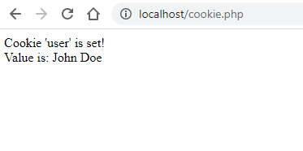

**PROGRAM 8: FILE READ, WRITE AND APPEND PROGRAM**

<?php

echo"<br>FILE CREATION";

touch('d:\file2.txt');

echo"<br>FILE CREATED";

echo"<br>OPENING AND WRITING INTO THE FILE";

$fp=fopen('d:\file2.txt',"w");

fwrite($fp,"Hello VLBJCAS <br> BCA DEPARTMENT");

fclose($fp);

echo"<br>OPENING AND APPENDING INTO THE FILE";

$fp=fopen('d:\file2.txt',"a");

fputs($fp,"\n<br> BCA students are good students");

fclose($fp);

echo"<br>READING FROM THE FILE<br>";

$fp=fopen('d:\file2.txt',"r")or die("CANT OPEN THE FILE");

while(!feof($fp))

{

$line=fread($fp,1024);

echo"<br>";

echo $line."<br/>";

}

fclose($fp);

?>

**OUTPUT:**





**PROGRAM 9: LOGO CREATION USING IMAGE FUNCTION**

<?php

header("Content-type:image/png");

$img_width=300;

$img_height=300;

$img=imagecreatetruecolor($img_width,$img_height);

$black=imagecolorallocate($img,0,0,0);

$white=imagecolorallocate($img,255,255,255);

$green=imagecolorallocate($img,0,255,0);

$blue=imagecolorallocate($img,0,0,255);

imagefill($img,0,0,$blue);

imageellipse($img,100,100,100,100,$white);

imagestring($img,20,75,90,'VLBJCAS',$white);

imagepng($img);

?>

**OUTPUT:**



**PROGRAM 10: STUDENT TABLE IN MYSQL**

<?php

$servername="localhost";

$username="root";

$password="";

$dbname="stu";

//Create connection

$conn=new mysqli($servername,$username,$password,$dbname);

// Check connection

if($conn->connect_error)

{

die("Connection failed:".$conn->connect_error);

}

$sql="SELECT*from bca";

$result=$conn->query($sql);

if($result->num_rows>0)

{

while($row=$result->fetch_assoc())

{

echo"<br>";

echo"Rollno:".$row["Rollno"]."---Name:".$row["name"]."<br>";

}

}

else

{

echo"0 results";

}

$conn->close();

?>

**OUTPUT:**

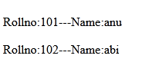

**PROGRAM 11: DISPLAY TABLE CONTENT USING STORED PROCEDURE**

<?php

$servername="localhost";

$username="root";

$password="";

$dbname="aaa";

$con=mysql_connect($servername,$username,$password,$dbname);

if (!$con)

{

die('Could not connect: ' . mysql_error());

}

mysql_select_db("aaa", $con);

print "<h2>MySQL: Simple Select statement</h2>";

$result = mysql_query("select * from Employee");

while($row = mysql_fetch_array($result))

{

echo $row['EmployeeID'] ."". $row['EmployeeName'] . "" . $row['Age'];

echo "<br/>";

}

print "<h2>MySQL: Creating Stored Procedure</h2>";

$qry = mysql_query("create procedure Employee_proc() select * from Employee");

echo "Stored Procedure created.";

mysql_query($qry,$con);

print "<h2>MySQL: Calling Stored procedure</h2>";

$res = mysql_query("call Employee_proc()");

while($row=mysql_fetch_array($res))

{

echo $row['EmployeeID'] ." ". $row['EmployeeName'] . " " . $row['Age'];

echo "<br/>";

}

mysql_close($con);

?>

**OUTPUT:**

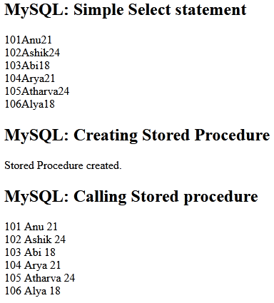

**PROGRAM 12: COLLEGE ADMISSION FORM**

**Index.php**

<html lang="en">

<head>

<title>GFG Store Data</title>

</head>

<body>

<center>

<h1>Storing Form Data in Database</h1>

<form action="insert11.php" method="post">

<p>

<label for="firstName">First Name : </label>

<input type="text" name="first_name" id="firstName">

</p>

<p>

<label for="lastName">Last Name : </label>

<input type="text" name="last_name" id="lastName">

</p>

<p>

<label for="Gender">Gender : </label>

<input type="text" name="gender" id="Gender">

</p>

<p>

<label for="Address">Address : </label>

<input type="text" name="address" id="Address">

</p>

<p>

<label for="emailAddress">Email Address : </label>

<input type="text" name="email" id="emailAddress">

</p>

<input type="submit" value="Submit" id="submit">

</form>

</center>

</body>

</html>

**Insert.php**

<html>

<head>

<title>Insert Page</title>

</head>

<body>

<center>

<?php

//server name = localhost

//user name = root

//password = empty

//database name = staff

$conn=mysqli_connect("localhost","root","","staff");

//Check connection

if($conn == false)

{

die("ERROR : Could not connect.".mysqli_connect_error());

}

//Taking all 5 values from the form data(input)

$first_name=filter_input(INPUT_POST,'first_name');

$last_name=filter_input(INPUT_POST,'last_name');

$gender=filter_input(INPUT_POST,'gender');

$address=filter_input(INPUT_POST,'address');

$email=filter_input(INPUT_POST,'email');

//Performing insert query execution

//Our table name is college

$sql="INSERT INTO college VALUES('$first_name','$last_name','$gender','$address','$email')";

if(mysqli_query($conn,$sql))

{

echo "<h3>Data stored in a database successfully."."Please browse your localhost php my admin"."to view the updated data</h3>";

echo("\n$first_name\n$last_name\n"."$gender\n$address\n$email");

}

else

{

echo "ERROR: Hush! Sorry $sql".mysqli_error($conn);

}

//Close connection

mysqli_close($conn);

?>

</center>

</body>

</html>

**Output:**

